HANOI UNIVERSITY OF SCIENCE AND TECHNOLOGY

School of Information and Communications Technology

Data Modeling

AIMS: An Internet Media Store

Software Design and Construction

Group 02

Trần Xuân Bách 20204634

Nguyễn Ngọc Quỳnh Anh 20204631

Nguyễn Vũ Thục Anh 20204631

Vũ Đức Anh 20193985

*Hanoi,* *1/2024*

Table of contents

Table of contents 1

1 Conceptual Data Model 2

2 Database Design 3

2.1 Logical Data Model 3

2.2 Physical Data Model 3

2.3 SQL: 8

# Conceptual Data Model

**AIMS System ERD**

# Database Design

## Logical Data Model

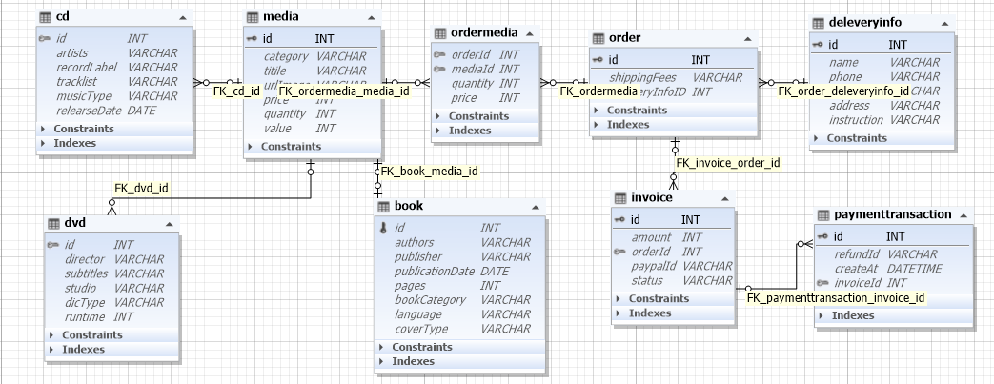

## Physical Data Model

* **Media**

|  |  |  |  |  |  |  |
| --- | --- | --- | --- | --- | --- | --- |
| # | PK | FK | Column Name | Data type | Mandatory | Description |
|  | x |  | id | int | yes | ID, auto increment |
|  |  |  | title | Varchar(45) | yes | Product's name |
|  |  |  | category | Varchar(45) | yes | Media type, eg., cd, DVD |
|  |  |  | value | int | yes | Value of the product |
|  |  |  | price | int | yes | Current price |
|  |  |  | quantity | int | yes | Number of products |
|  |  |  | productDimensions | Varchar(45) | yes | horizontal, length, width dimensions |
|  |  |  | description | Varchar(45) | yes | Product description |
|  |  |  | imageURL | Varchar(45) | yes | Product image path |
|  |  |  | createAt | timestamp | yes | The time the product is added to the system |
|  |  |  | updateAt | timestamp | no | The time the product is updated to the system |

* **CD**

|  |  |  |  |  |  |  |
| --- | --- | --- | --- | --- | --- | --- |
| # | PK | FK | Column Name | Data type | Mandatory | Description |
|  |  | x | id | int | yes | ID, same as ID of Media of twhich type is CD |
|  |  |  | type | Varchar(45) | yes | Music genres |
|  |  |  | artist | Varchar(45) | yes | Artist's name |
|  |  |  | dateRelease | datetime | No | Release date |
|  |  |  | recordLabel | Varchar(45) | yes | Record label |

* **LD**

|  |  |  |  |  |  |  |
| --- | --- | --- | --- | --- | --- | --- |
| # | PK | FK | Column Name | Data type | Mandatory | Description |
|  |  | x | id | int | yes | ID, same as ID of Media of twhich type is CD |
|  |  |  | type | Varchar(45) | yes | Music genres |
|  |  |  | artist | Varchar(45) | yes | Artist's name |
|  |  |  | dateRelease | datetime | No | Release date |
|  |  |  | recordLabel | Varchar(45) | yes | Record label |

* **Book**

|  |  |  |  |  |  |  |
| --- | --- | --- | --- | --- | --- | --- |
| # | PK | FK | Column Name | Data type | Mandatory | Description |
|  |  | x | id | int | yes | ID, same as ID of Media of which type is Book |
|  |  |  | authors | Varchar(45) | yes | Authors of the book |
|  |  |  | publisher | Varchar(45) | yes | Publishing house |
|  |  |  | language | Varchar(45) | yes | Language |
|  |  |  | type | Varchar(45) | yes | Cover type |
|  |  |  | cover | Varchar(45) | yes | Book cover |
|  |  |  | page | int | yes | Page number |
|  |  |  | publishDate | datetime | yes | Date of publishing |

* **dvd**

|  |  |  |  |  |  |  |
| --- | --- | --- | --- | --- | --- | --- |
| # | PK | FK | Column Name | Data type | Mandatory | Description |
|  |  | x | id | int | yes | ID, same as ID of Media of which type is DVD |
|  |  |  | discType | VARCHAR(45) | yes | Disc type |
|  |  |  | director | VARCHAR(45) | Yes | Director |
|  |  |  | runtime | int | Yes | Duration |
|  |  |  | subtitles | VARCHAR(45) | Yes | Subtitles |
|  |  |  | studio | VARCHAR(45) | yes | Manufacturer |
|  |  |  | releaseDate | Datetime | Yes | Release date |
|  |  |  | filmType | VARCHAR(45) | yes | Genres |

* **deliveryinfo**

|  |  |  |  |  |  |  |
| --- | --- | --- | --- | --- | --- | --- |
| # | PK | FK | Column Name | Data type | Mandatory | Description |
|  | x |  | id | int | yes | ID, auto increment |
|  |  |  | receiverName | Varchar(45) | yes | Receiver name |
|  |  |  | number | Varchar(10) | yes | Receiver phone number |
|  |  |  | province | Varchar(45) | yes | Provinces |
|  |  |  | address | Varchar(45) | yes | Delivery address |
|  |  |  | instruction | Varchar(100) | yes | Delivery instructions |
|  |  |  | isRushOrder | tinyint(1) | yes | Is Place Rush Order |
|  |  |  | shippingTimeRush | datetime | no | Delivery Time for RO |
|  |  |  | createAt | timestamp | yes |  |
|  |  |  | updateAt | timestamp | yes |  |

* **order**

|  |  |  |  |  |  |  |
| --- | --- | --- | --- | --- | --- | --- |
| # | PK | FK | Column Name | Data type | Mandatory | Description |
|  | x |  | id | int | yes | Id, auto increment |
|  |  |  | shippingFee | int | yes | Shipping Fee |
|  |  |  | price | int | yes | Selling price |
|  |  |  | totalPrice | int | yes | Selling price + VAT |
|  |  | x | deliveryId | int | yes | Delivery Info ID |
|  |  |  | createAt | timestamp |  |  |
|  |  |  | updateAt | timestamp |  |  |

* **order_media**

|  |  |  |  |  |  |  |
| --- | --- | --- | --- | --- | --- | --- |
| # | PK | FK | Column Name | Data type | Mandatory | Description |
|  |  | x | orderId | int | yes | Order ID |
|  |  | x | mediaId | int | yes | Media ID |
|  |  |  | quanity | int | yes | Number |
|  |  |  | price | int | yes | Selling price |

* **invoice**

|  |  |  |  |  |  |  |
| --- | --- | --- | --- | --- | --- | --- |
| # | PK | FK | Column Name | Data type | Mandatory | Description |
|  | x |  | id | int | yes | ID |
|  |  |  | amount | int | yes | Total |
|  |  | x | orderId | int | yes | Order ID |
|  |  |  | staus | Varchar(45) | yes | Order status |

* **paymenttransaction**

|  |  |  |  |  |  |  |
| --- | --- | --- | --- | --- | --- | --- |
| # | PK | FK | Column Name | Data type | Mandatory | Description |
|  | x |  | id | int | yes | ID |
|  |  |  | createAt | timestamp | yes | Date of creation |
|  |  |  | refundId | Varchar(45) | yes | Transaction contents |
|  |  | x | invoiceId | int | yes | Invoice ID |

## SQL:

|  |
| --- |
| BEGIN TRANSACTION;  CREATE TABLE IF NOT EXISTS "Media" (  "id" INTEGER NOT NULL,  "type" VARCHAR(45) NOT NULL,  "category" VARCHAR(45) NOT NULL,  "price" INTEGER NOT NULL,  "quantity" INTEGER NOT NULL,  "title" VARCHAR(45) NOT NULL,  "value" INTEGER NOT NULL,  "imageUrl" VARCHAR(45) NOT NULL,  PRIMARY KEY("id" AUTOINCREMENT)  );  CREATE TABLE IF NOT EXISTS "CD" (  "id" INTEGER NOT NULL,  "artist" VARCHAR(45) NOT NULL,  "recordLabel" VARCHAR(45) NOT NULL,  "musicType" VARCHAR(45) NOT NULL,  "releasedDate" DATE,  CONSTRAINT "fk_cd_media" FOREIGN KEY("id") REFERENCES "Media"("id"),  PRIMARY KEY("id")  );  CREATE TABLE IF NOT EXISTS "Book" (  "id" INTEGER NOT NULL,  "author" VARCHAR(45) NOT NULL,  "coverType" VARCHAR(45) NOT NULL,  "publisher" VARCHAR(45) NOT NULL,  "publishDate" DATETIME NOT NULL,  "numOfPages" INTEGER NOT NULL,  "language" VARCHAR(45) NOT NULL,  "bookCategory" VARCHAR(45) NOT NULL,  CONSTRAINT "fk_book_media" FOREIGN KEY("id") REFERENCES "Media"("id"),  PRIMARY KEY("id" AUTOINCREMENT)  );  CREATE TABLE IF NOT EXISTS "DVD" (  "id" INTEGER NOT NULL,  "discType" VARCHAR(45) NOT NULL,  "director" VARCHAR(45) NOT NULL,  "runtime" INTEGER NOT NULL,  "studio" VARCHAR(45) NOT NULL,  "subtitle" VARCHAR(45) NOT NULL,  "releasedDate" DATETIME,  "filmType" VARCHAR(45) NOT NULL,  CONSTRAINT "fk_dvd_media" FOREIGN KEY("id") REFERENCES "Media"("id"),  PRIMARY KEY("id")  );  CREATE TABLE IF NOT EXISTS "OrderMedia" (  "mediaID" INTEGER NOT NULL,  "orderID" INTEGER NOT NULL,  "price" INTEGER NOT NULL,  "quantity" INTEGER NOT NULL,  CONSTRAINT "fk_ordermedia_media" FOREIGN KEY("mediaID") REFERENCES "Media"("id"),  CONSTRAINT "fk_ordermedia_order" FOREIGN KEY("orderID") REFERENCES "Order"("id"),  PRIMARY KEY("mediaID","orderID")  );  CREATE TABLE IF NOT EXISTS "Order" (  "id" INTEGER NOT NULL,  "name" VARCHAR(45) NOT NULL,  "address" VARCHAR(45) NOT NULL,  "phone" VARCHAR(45) NOT NULL,  "shipping_fee" INTEGER NOT NULL,  PRIMARY KEY("id" AUTOINCREMENT)  );  CREATE TABLE IF NOT EXISTS "Transaction" (  "id" INTEGER NOT NULL,  "invoiceId" INTEGER NOT NULL,  "createAt" DATETIME NOT NULL,  "refundId" VARCHAR(45) NOT NULL,  CONSTRAINT "fk_transaction_invoice" FOREIGN KEY("orderId") REFERENCES "Invoice"("id"),  PRIMARY KEY("id" AUTOINCREMENT)  );  CREATE TABLE IF NOT EXISTS "Invoice" (  "id" INTEGER NOT NULL,  "orderId" INTEGER,  "amount" INTEGER,  "paypalId" VARCHAR(50),  "status" VARCHAR(50),  CONSTRAINT "fk_invoice_order" FOREIGN KEY("orderId") REFERENCES "Order"("id"),  PRIMARY KEY("id" AUTOINCREMENT)  );  COMMIT; |